|  |  |
| --- | --- |
| **Name:** | MANSI UNIYAL |
| **Roll Number:** | 19EE10039 |

**Experiment No. 9**

**Name of the Experiment: Study of basic properties of operational amplifier:**

**inverting and non-inverting amplifiers**

1. **Aim of the experiment**

* Explain Inverting Op amp
* Explain Non- Inverting Op amp
* Explain Gain

1. **Tools used:**

* Stimulation: V-labs
* Connecting wires
* Resistance
* Voltmeter
* Ammeter
* Op amp

1. 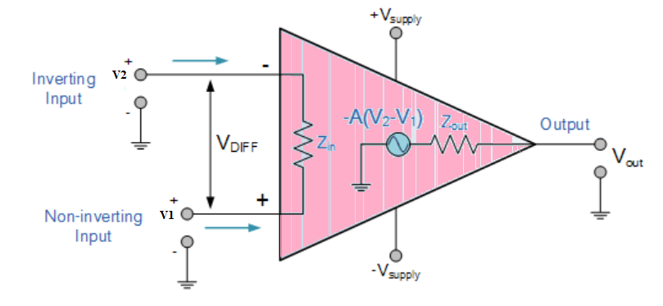**Background knowledge (brief):**

**Operational Amplifier (Op-Amp)**

* It has three terminals, two high impedance input and one output terminal.
* Can perform multiple function when attached to different feedback combinations like resistive, capacitive or both.
* Used as voltage amplifier and the output voltage of the Op-Amp is the difference between the voltages at its two input terminals.
  + Open loop gain and input impedance is infinite (practically very high),
  + Output impedance and offset voltage is zero (practically very low)
  + Bandwidth is infinite (practically limited to frequency where its gain become unity).

**Inverting Op-Amp**

* Open loop gain of the Om-Amp is very high 🡪 makes it very unstable
* 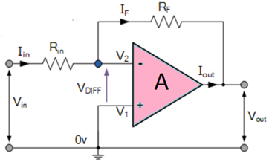Thus, feedback is applied via external resistor (Rf) from its output to inverting input terminal (negative feedback) 🡪 reduced gain (closed loop gain, Av).
* Voltage at inverting terminal = actual input + feedback voltages
* To separate both an input resistor (Ri) is introduced in the circuit.
* Non-inverting terminal 🡪 grounded,
* Inverting terminal behaves like a virtual ground as the junction of the input and feedback signal are at the same potential.

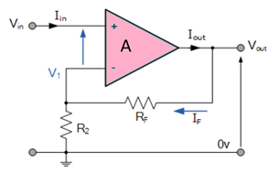**Non-Inverting Op-Amp**

* Input signal is fed to the non-inverting terminal resulting in a positive gain.
* Output voltage is in phase.
* To stabilize the circuit, negative feedback is applied through a resistor (Rf).
* Inverting terminal is grounded with an input resistor(R2).

1. **Circuit (hand drawn/image)**

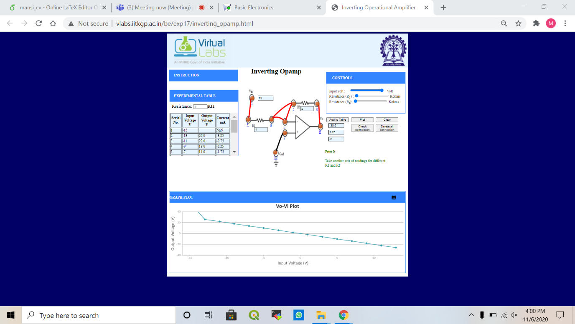 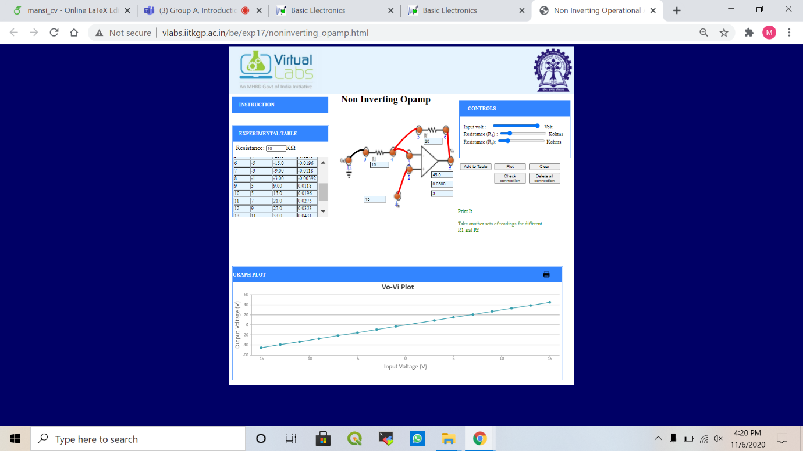

Inverting Op amp Non-Inverting Op amp

1. **Measurement Data (Tabular form)**

* Inverting Op amp
  + Gain: -2
    - Rf = 2, R1 = 1

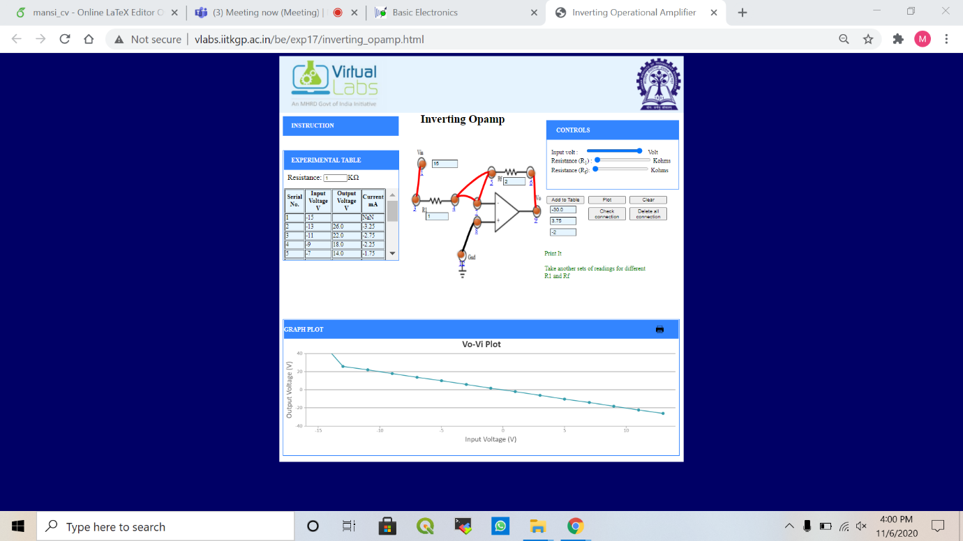

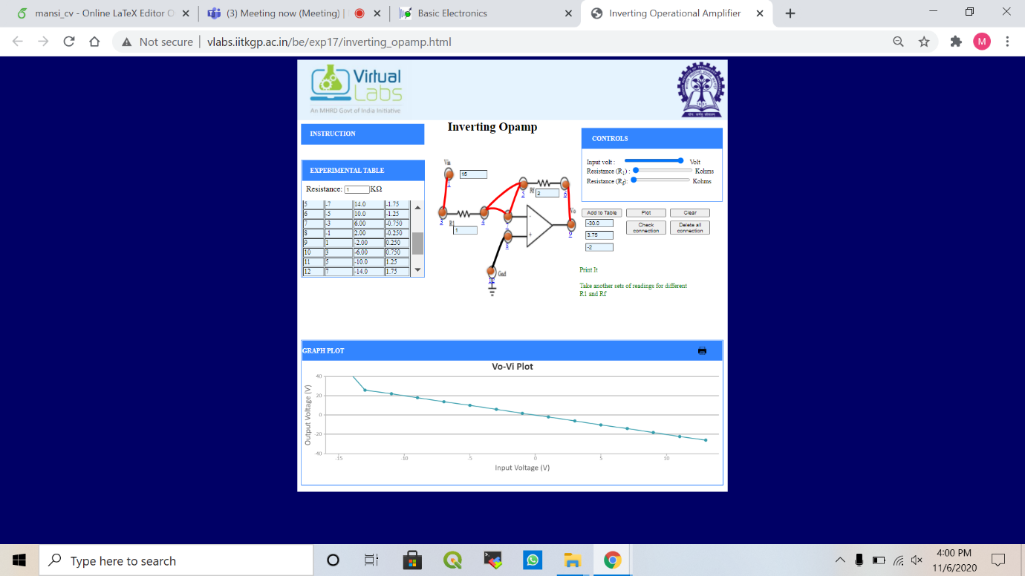

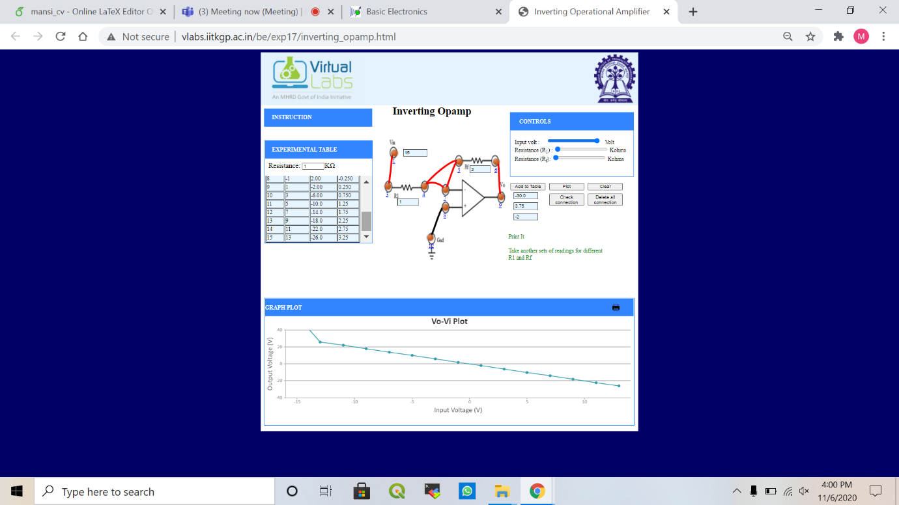

* + Gain: -1
    - Rf = 2, R1 = 2

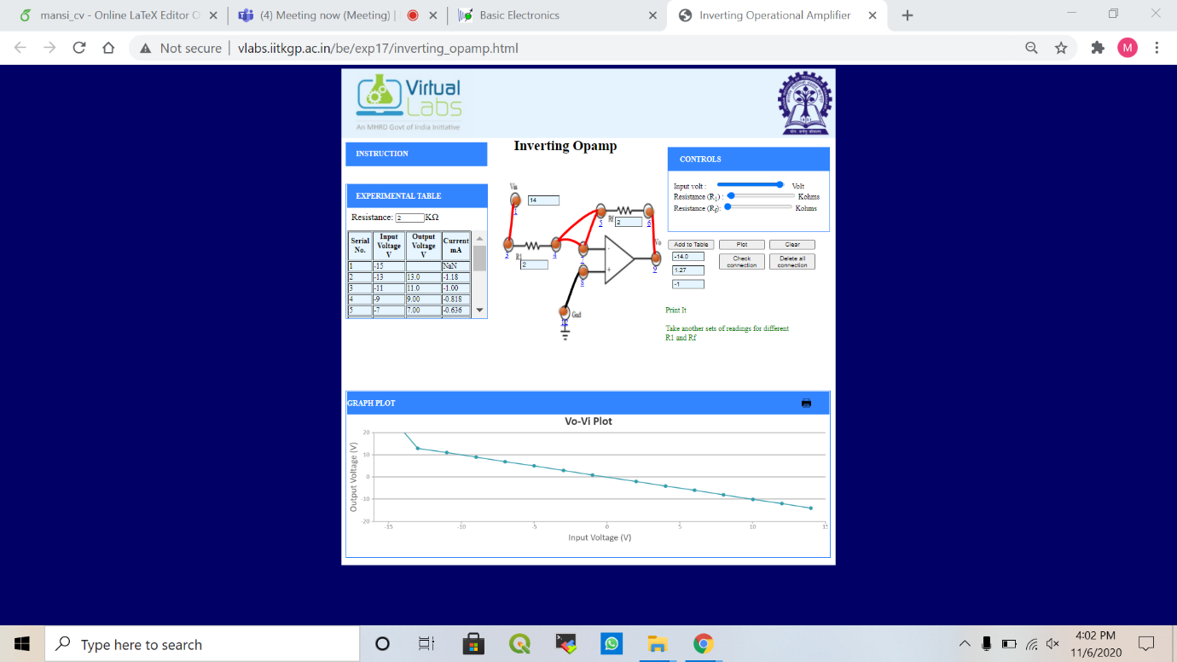

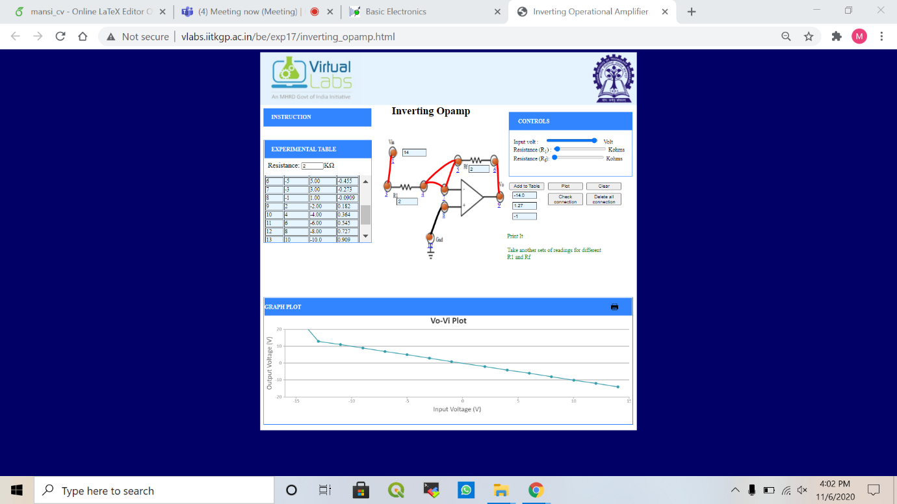

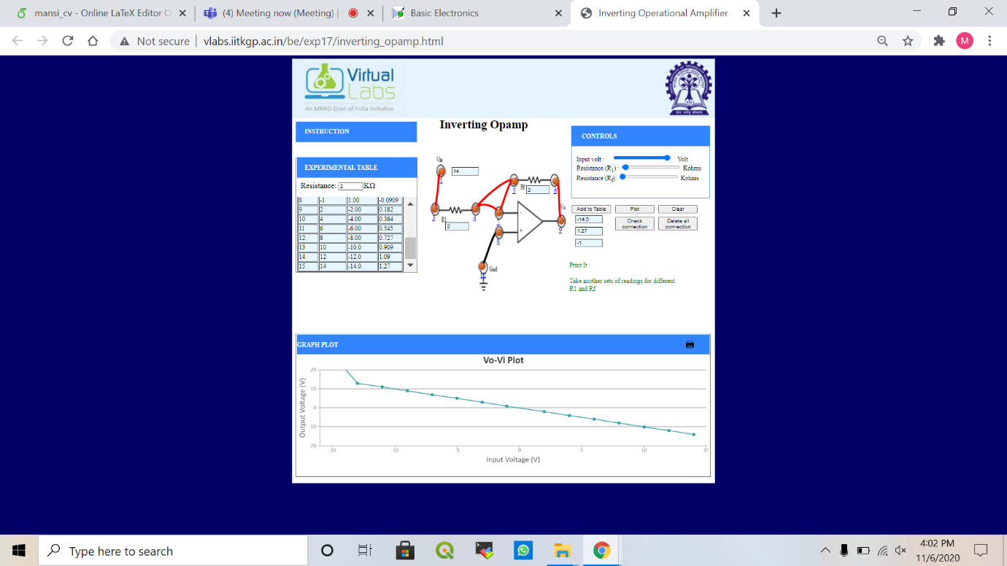

* + Gain: -0.5
    - Rf = 2, R1 = 4

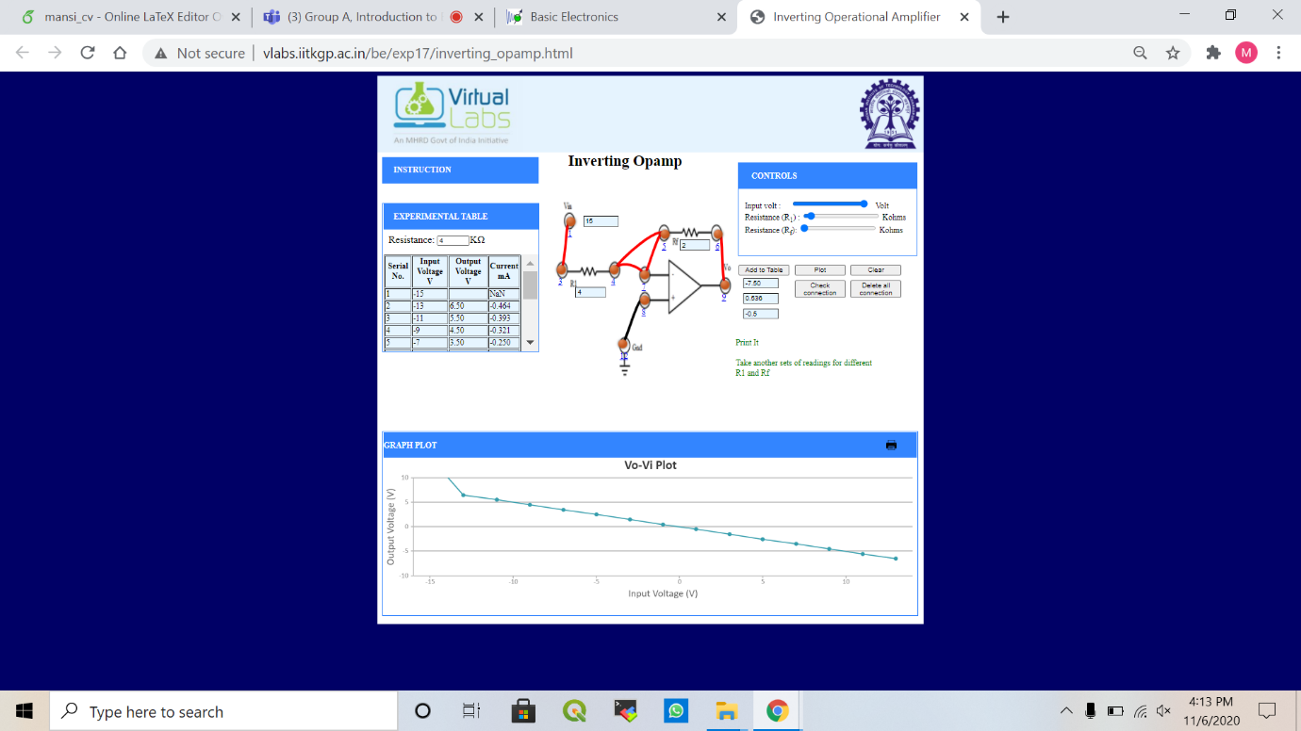

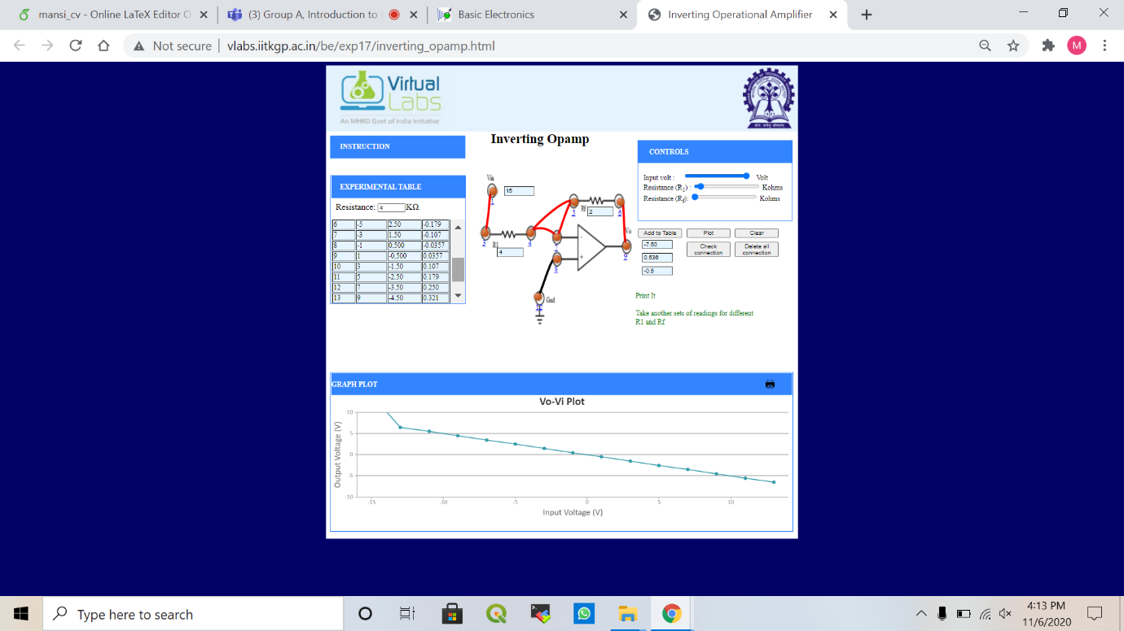

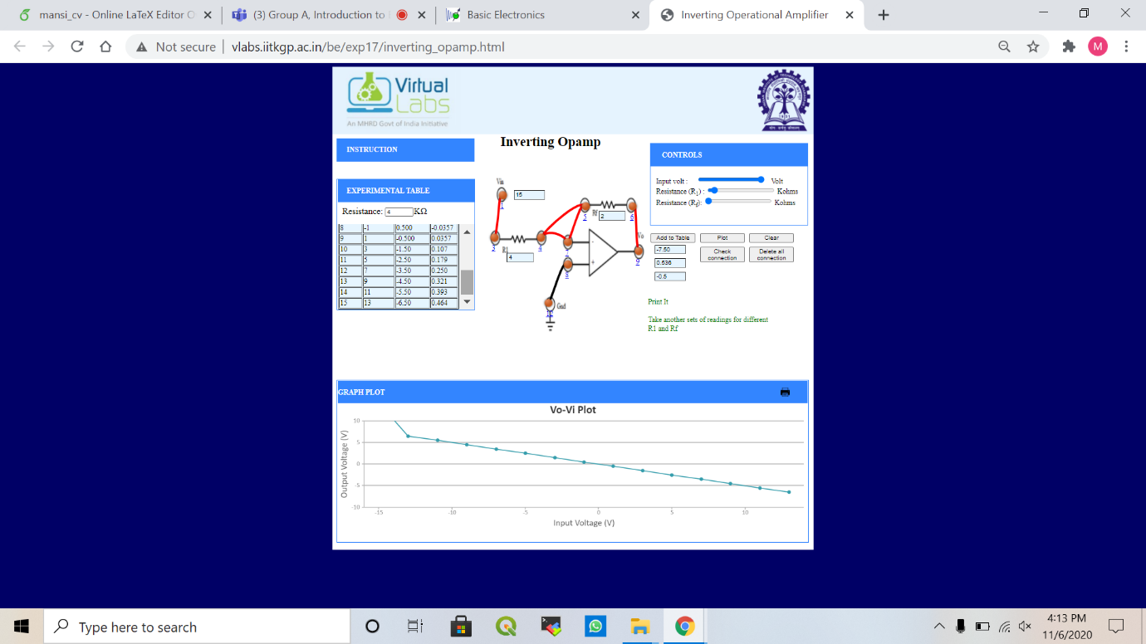

* Non-Inverting Op amp
  + Gain: 2
    - Rf = 20, R1 = 10

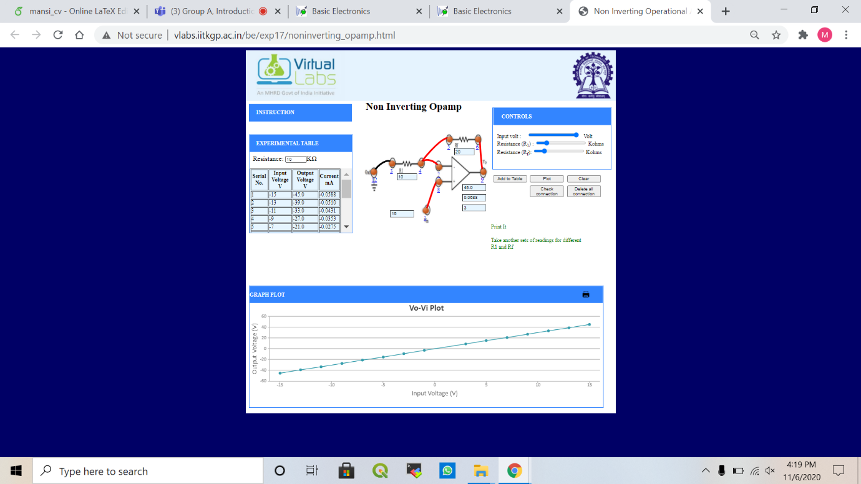



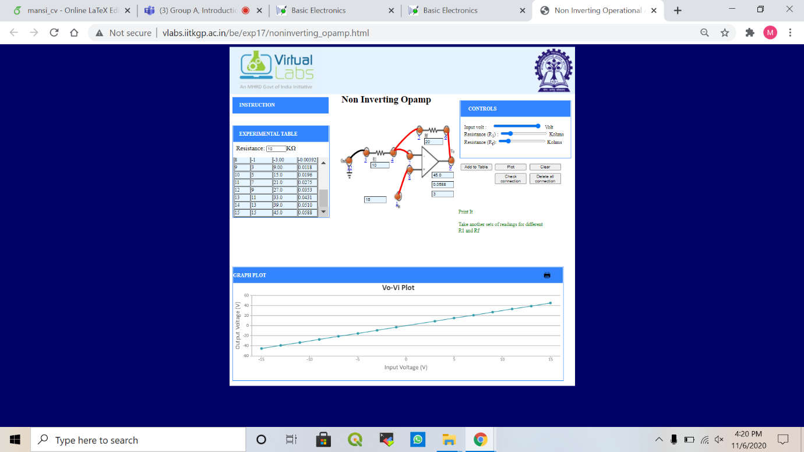

* + Gain: 1
    - Rf = 20, R1 = 20

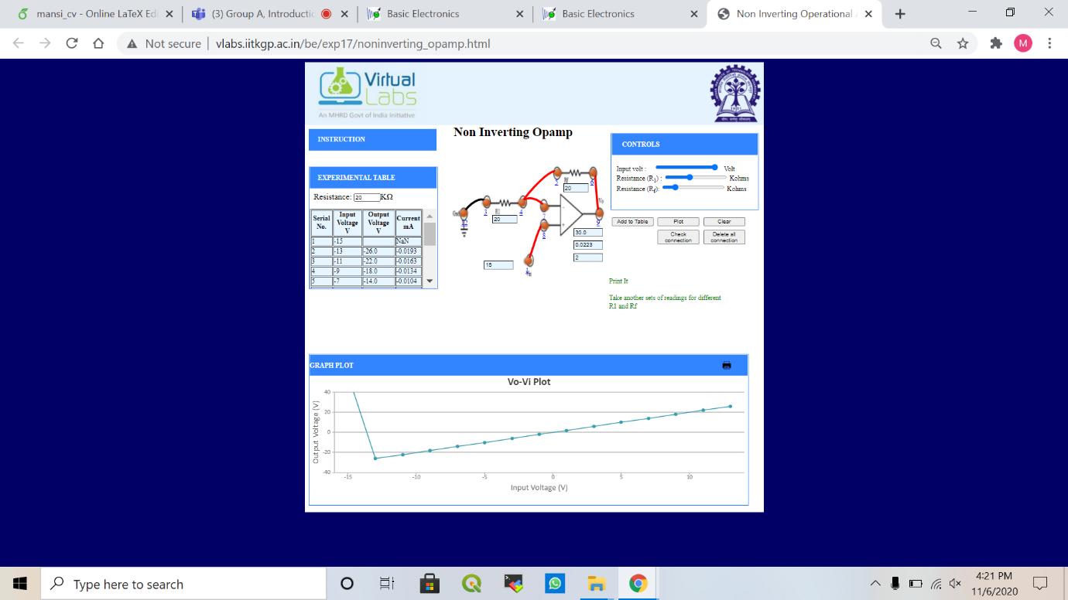

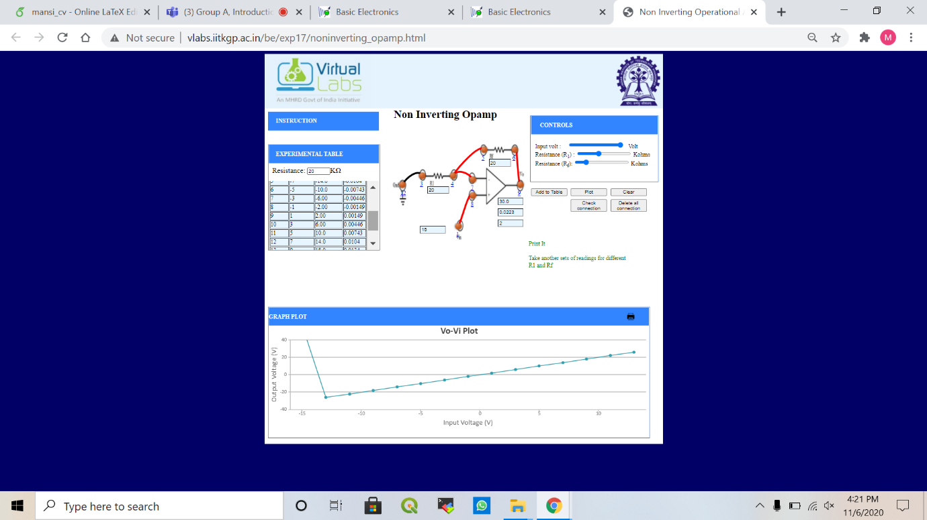

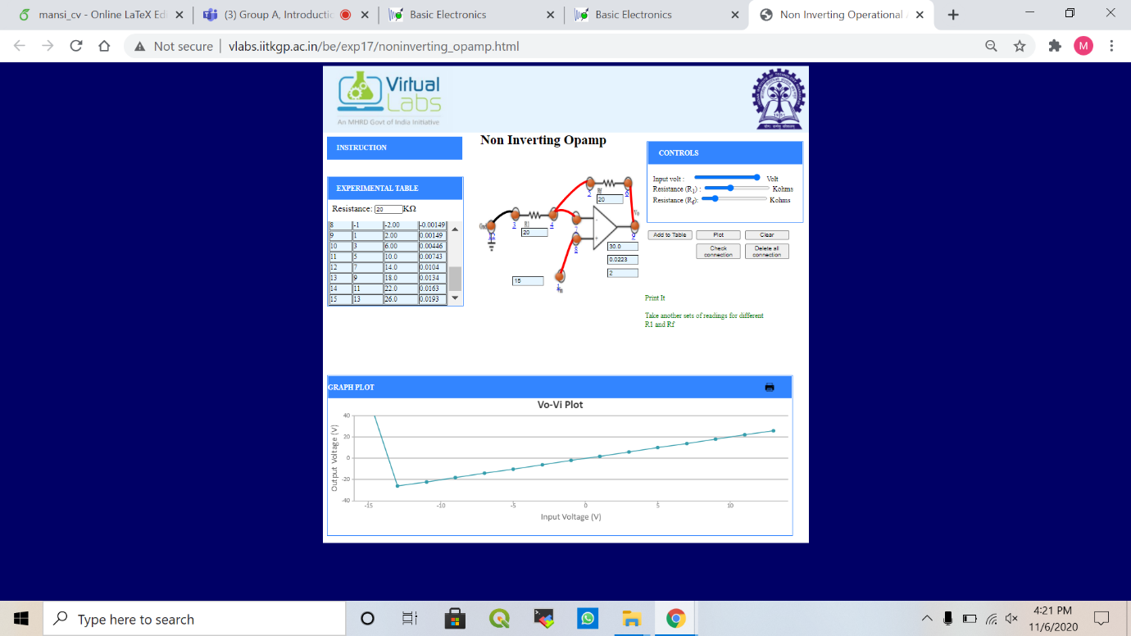

* + Gain: 0.5
    - Rf = 20, R1 = 40

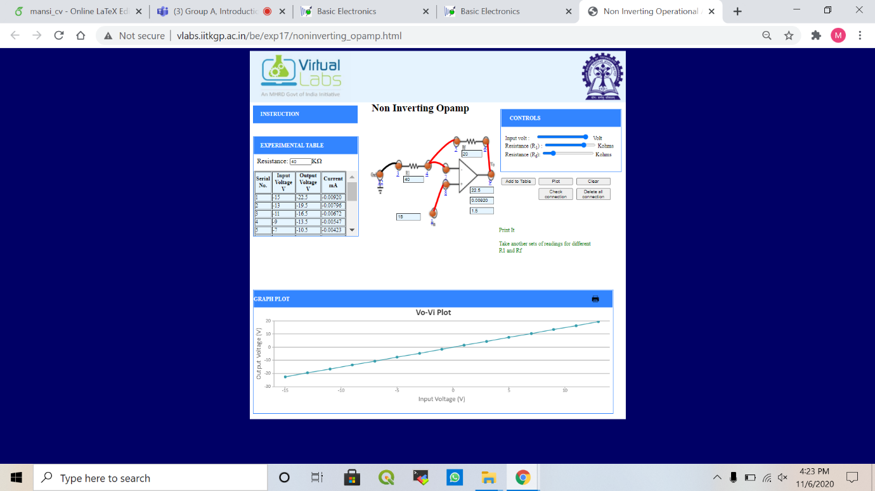

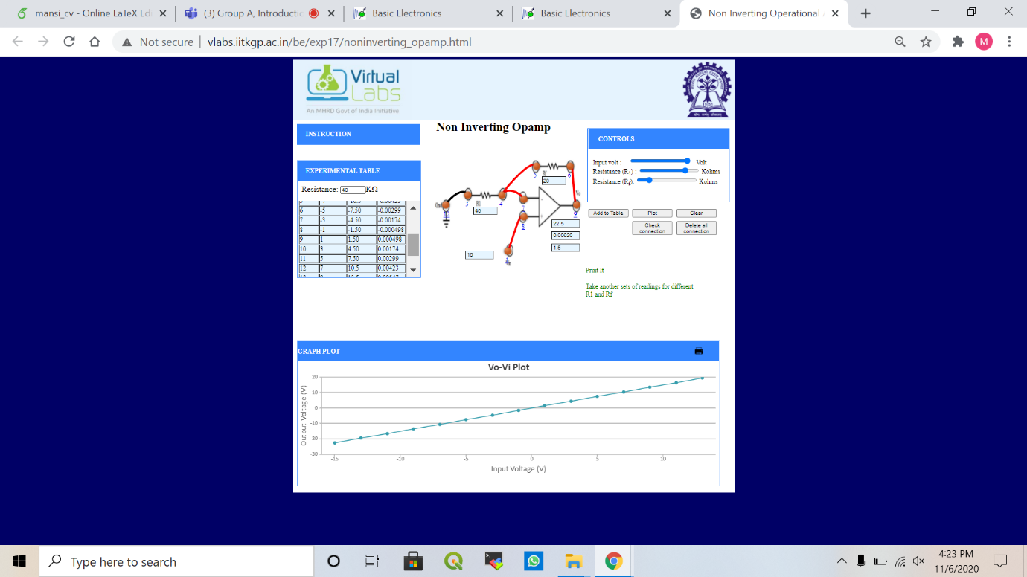

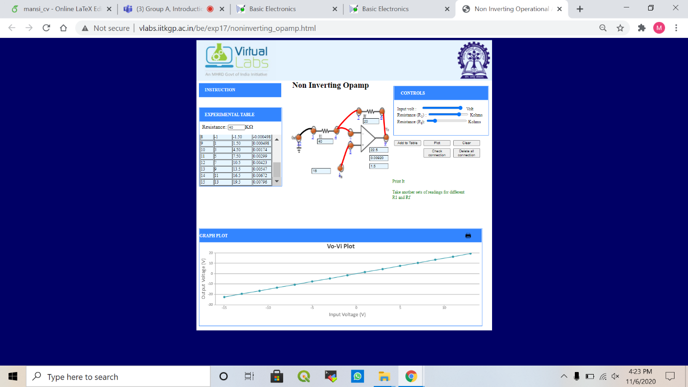

1. **Graph (Image)/Screenshots**

* Inverting Op amp
  + Gain: -2
    - Rf = 2, R1 = 1



* + Gain: -1
    - Rf = 2, R1 = 2



* + Gain: -0.5
    - Rf = 2, R1 = 4



* Non-Inverting Op amp
  + Gain: 2
    - Rf = 20, R1 = 10



* + Gain: 1
    - Rf = 20, R1 = 20



* + Gain: 0.5
    - Rf = 20, R1 = 40



1. **Conclusion**

* Inverting Op amp

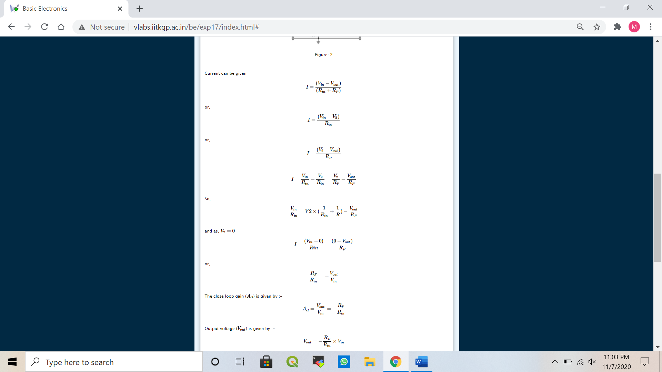







Thus, the gain is negative.

* Non-Inverting Op amp

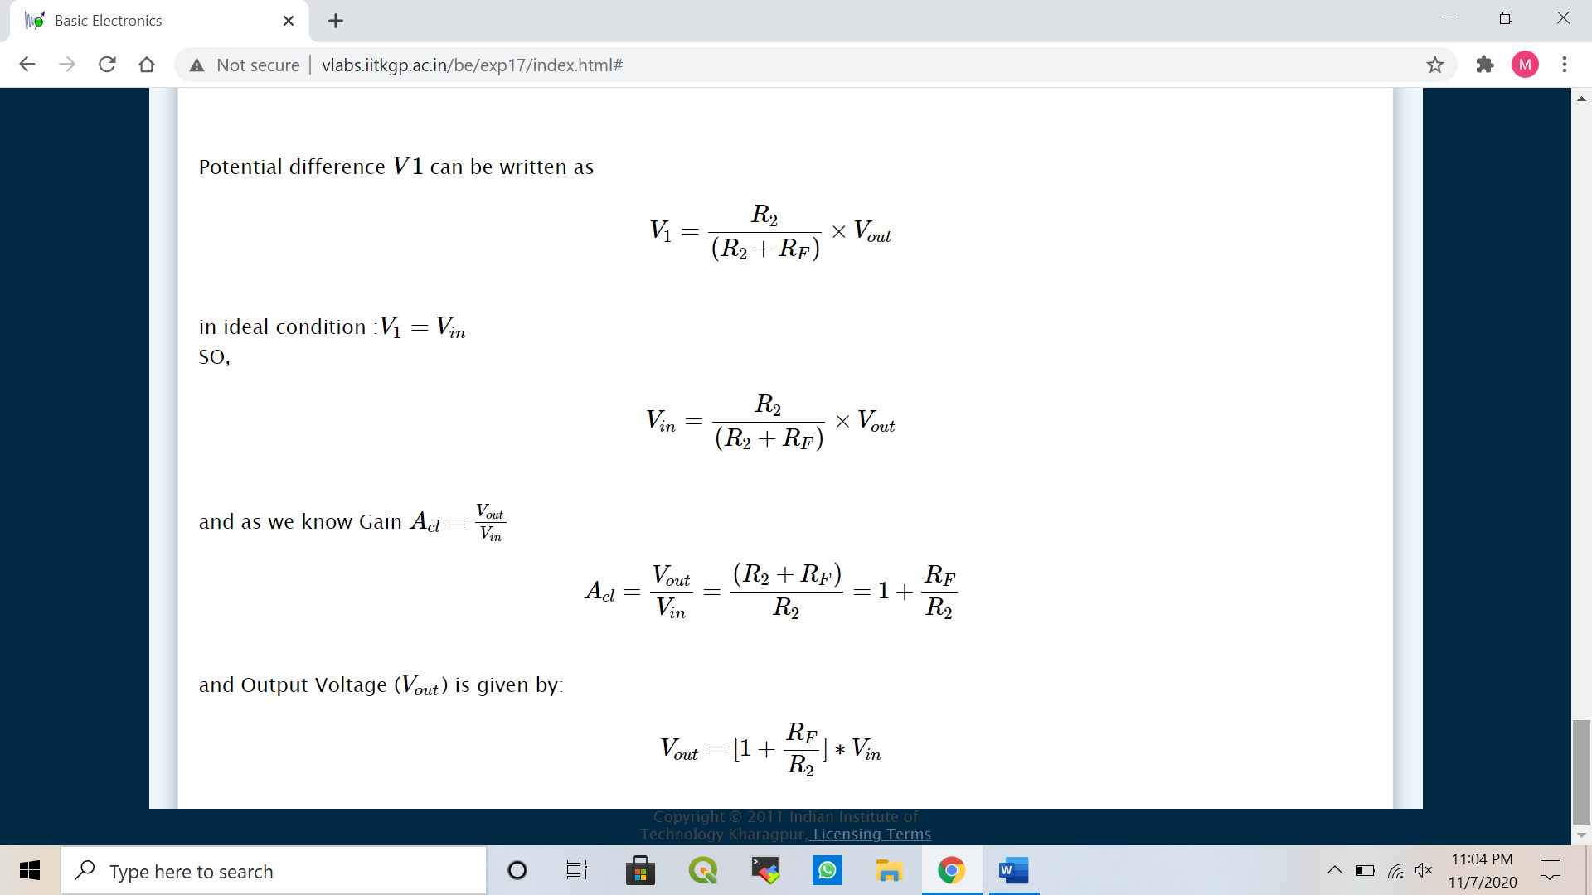

Thus, the gain is positive.

1. **Discussions**

* Gain of Inverting Op amp is negative
* Output voltage is out of phase for Inverting Op amp.
* Gain of Non-Inverting Op amp is positive
* Output voltage is in phase for Non-Inverting Op amp.